|  |  |
| --- | --- |
| USE CASE | DownloadImage |
| ID | UC1 |
| BRIEF DESCRIPTION | A member of hospital staff wants to download post-surgery images to determine success of surgery. |
| PRIMARY ACTORS | Clinician |
| SECONDARY ACTORS | Researcher |
| PRECONDITIONS | The user must be connected to the internet. |
| MAIN FLOW | 1) The user selects the option to view images on the cloud.  2) The user selects images to download locally.  3) Images are saved locally on the device. |
| POST CONDITIONS | None |
| ALTERNATIVE FLOWS | None |

|  |  |
| --- | --- |
| USE CASE | SymmetryScore |
| ID | UC2 |
| BRIEF DESCRIPTION | A member of hospital staff wants to determine the success of a surgery from an image. |
| PRIMARY ACTORS | Clinician |
| SECONDARY ACTORS | Researcher |
| PRECONDITIONS | The user must have saved an image locally. |
| MAIN FLOW | 1) The user selects a locally stored image.  2) The user selects the option to create a drawing of lip regions.  3) The user draws around the lip regions.  4) The user selects the option to generate symmetry scores.  5) Symmetry scores displayed. |
| POST CONDITIONS | None |
| ALTERNATIVE FLOWS | SymmetryScore:BadDrawing |

|  |  |
| --- | --- |
| USE CASE | SymmetryScore:BadDrawing |
| ID | UC2.1 |
| BRIEF DESCRIPTION | A member of hospital staff drew around the lip regions incorrectly |
| PRIMARY ACTORS | Clinician |
| SECONDARY ACTORS | Researcher |
| PRECONDITIONS | The user wants to redraw around the lip regions. |
| MAIN FLOW | 1) The user draws around the lip regions incorrectly.  2) The user selects the option to redraw around the lip regions.  3) The use case is repeated until the user is satisfied with the drawing and selects the option to generate symmetry scores.  4) Symmetry scores displayed. |
| POST CONDITIONS | None |
| ALTERNATIVE FLOWS | SymmetryScore:BadDrawing |

|  |  |
| --- | --- |
| USE CASE | SyncLocalData |
| ID | UC3 |
| BRIEF DESCRIPTION | A member of hospital staff wants to upload offline content to the cloud |
| PRIMARY ACTORS | Clinician |
| SECONDARY ACTORS | Researcher |
| PRECONDITIONS | The user must be connected to the internet |
| MAIN FLOW | 1) The user chooses the option to sync data.  2) Newly generated offline drawings and symmetry scores, if any, are uploaded to the cloud. |
| POST CONDITIONS | None |
| ALTERNATIVE FLOWS | None |

|  |  |
| --- | --- |
| USE CASE | DrawingAnalytics |
| ID | UC4 |
| BRIEF DESCRIPTION | A researcher wants to compare symmetry scores generated by each user for a single image. |
| PRIMARY ACTORS | Researcher |
| SECONDARY ACTORS | None |
| PRECONDITIONS | The user must have admin privileges to the cloud. |
| MAIN FLOW | 1) The user selects the option to download analysis data for a specific image.  2) Data from the image’s drawings and corresponding symmetry scores are downloaded locally in a form that allows easy comparison. |
| POST CONDITIONS | None |
| ALTERNATIVE FLOWS | None |

User stories:

As a researcher I want to easily be able to view relevant input and output data for images so that I can analyse the results without much hassle.

As a researcher I want to be able to compare relevant data for the same image so that I can determine how a specific change in the input changed the output result.

As a clinician I want to be able to use the app without having to spend a long time learning how to use it so that I can save time.

As a clinician I want to obtain symmetry scores on a patient’s image quickly without having to go through large amounts of options so that I can use the app without much hassle.

Sequence diagram: 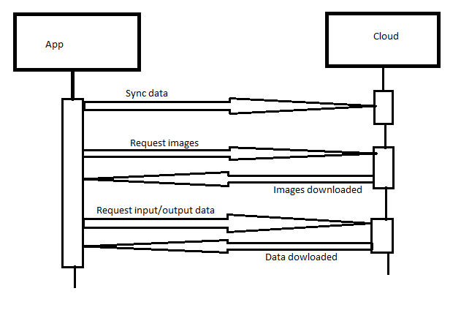

Three sentence summary:

The project is about determining the success of cleft lip and palate surgeries. Through the use of a mobile app, paediatric plastic surgeons should be able to evaluate the aesthetic outcome of the surgery by determining how symmetrical the lips are. The user should be able to draw around the lip region of the target image and then receive a set of symmetry scores, determining the successfulness of the surgery.